**상관 서브쿼리(not Exists)**

1. **select *from sample551;**
2. **select *from sample552;**

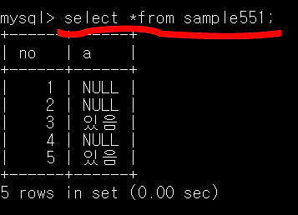 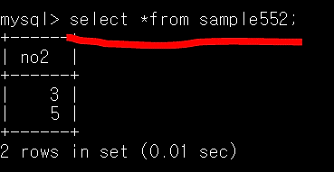

1. **update sample551 set a = ‘없음’ where**

**not exists(select *from sample552 where no2 = no);**

1. **select *from sample551;**

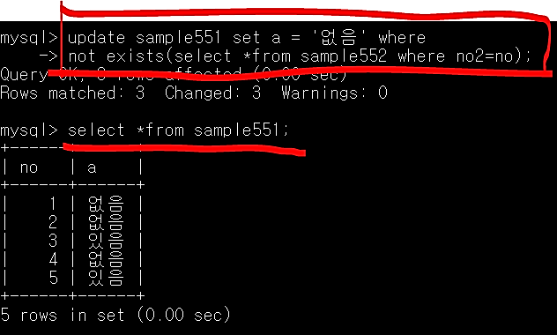

Not Exists 🡪 행마다 조사, 열끼리 비교하여 불일치하면 참을 반환 (일치하면 거짓)